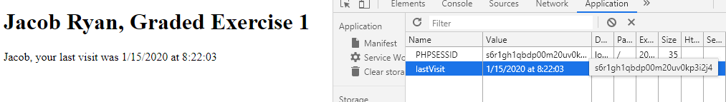

<!doctype html>

<html>

<head>

<!--

CIS213 Unit 4, Graded Exercise 1

Author: Jacob Ryan

Date: 1/13/2020

-->

<meta charset="="utf-8" />

<meta id="viewport" content="width=device-width, initial-scale=1.0, maximum=scale=1.0,user-scalable=0">

<title>Unit 4, Graded Exercise 1</title>

</head>

<body>

<header>

<h1>Jacob Ryan, Graded Exercise 1</h1>

</header>

<article>

<label id="output">Jacob, this is your first visit</label>

</article>

<script>

function populateInfo()

{

var now = new Date();

var day = now.getDay();

var date = now.getDate();

var month = now.getMonth();

var year = now.getFullYear();

var timeStr = now.toTimeString();

var lastVisit;

lastVisit = month + "/" + date + "/" + year + " at " + timeStr.substring(timeStr.indexOf("at") + 2, 8);

document.cookie = "lastVisit=" + lastVisit;

document.getElementById("output").innerHTML = "Jacob, your last visit was " + lastVisit;

}

if (window.addEventListener)

{

window.addEventListener("load", populateInfo, false);

)

else if (window.attachEvent)

{

window.attachEvent("onload", populateInfo);

}

</script>

</body>

</html>